- Go to
M
Mercredi 21

EDA Dairy Policy Conference 2018

‘European Dairy - Our way forward’
EDA Dairy Policy Conference 2018
#EDAConf18

Wednesday 21 March 2018 │ 14.00 – 17.00 │ Brussels
Venue: Espace Banca Monte Paschi, 22-28 avenue d’Auderghem

‘European Dairy - Our way forward’

Confirmed speakers include:
Tom Tynan, member of the cabinet of EU Commissioner Phil Hogan
Dr Tzvetan Dimitrov, Deputy Minister – Ministry of Agriculture, Food and Forestry, Bulgaria
Peter Giortz-Carlsen, Executive Vice President Europe, Arla Foods
Jacques Creyssel, CEO Fédération du Commerce et de la Distribution (FCD, French retailer organisation)

Cheese Buffet 17.00 – 20.30

Check out the programme:

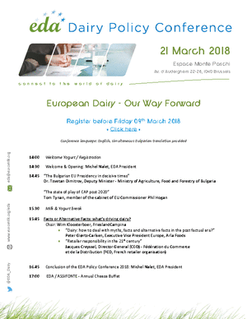

Registrations closed on Friday 9 March 2018

